The manual for human rights commission search engine
About the search engine
The system was developed by Hostalite limited.
The system was developed in drupal to come up with the interface and functionalities then MYSQL to design the database.
The system works on all platforms of operating system i:e windows, Linux and Mac os
It uses all browsers i:e Mozilla, chrome, safari, internet explorer and others.

Requirements for using the search engine
- Computer connected to the internet.
- One to use the search engine has to be with computer knowledge.
- One must be able to read and write English language.
- In order to access the system, open any browser and type the search engine url then press enter.
- You will be taken to the page in the picture below.

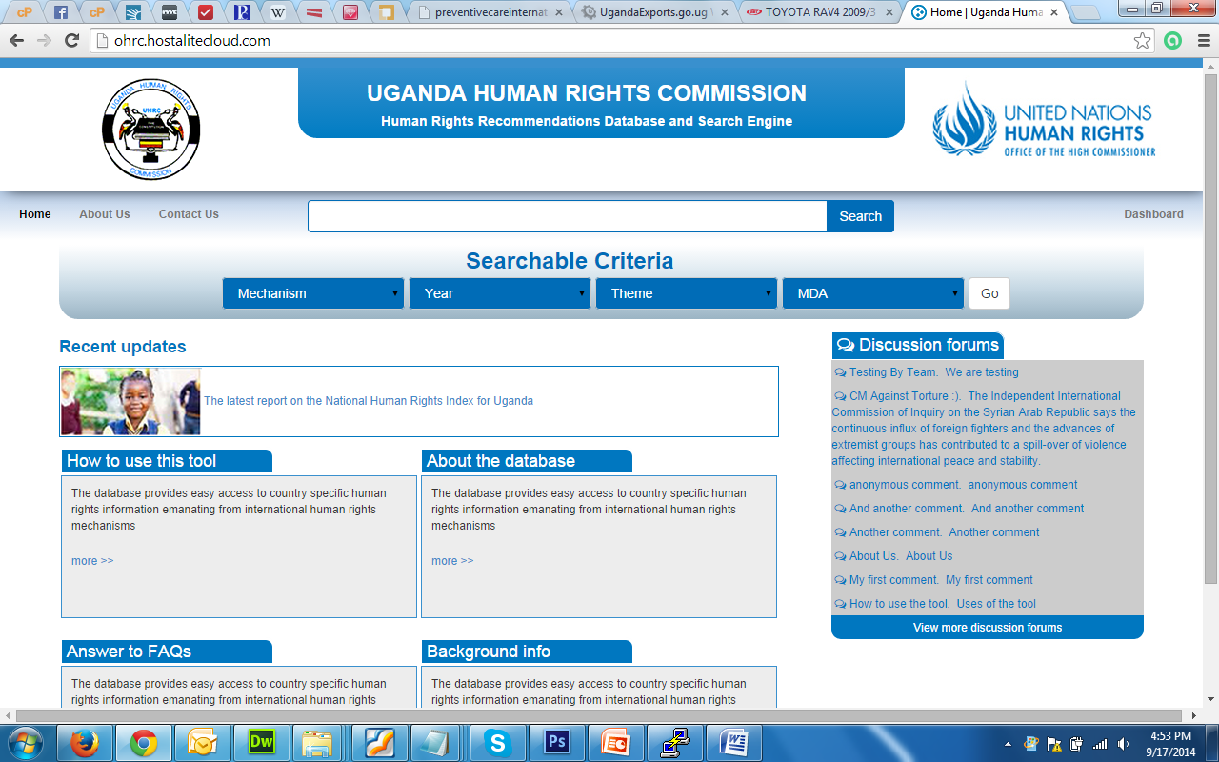
General Search select theme
Select mechanism select year select MDA click go to search

After selecting and the go button have been clicked you will see a page containing results that match your selection as shown below.
This page still allows you to amend your search by reducing or adding on the results.
This page has side bar where a user can make selections on how to search while in the data grid.

Refine search export to excel export to word dashboard

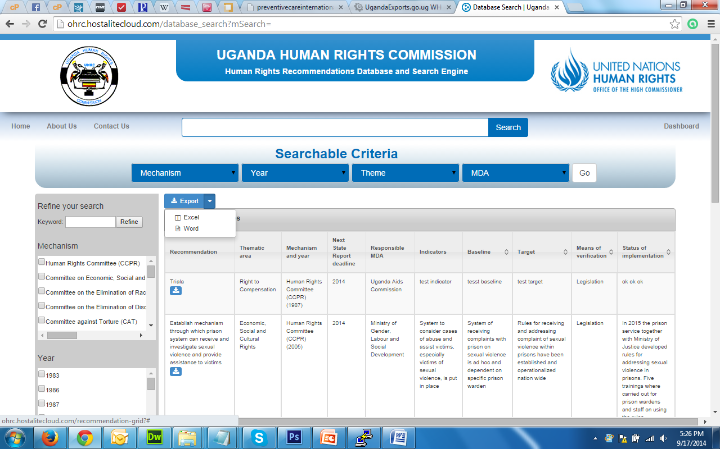
Loads grid on full page
When you click on the dashboard you will be prompted to login using password and username.
After logging in you will able to perform crued functionalities that is create, update, edit and delete. below is the illustration.

Dashboard view recommend Add user logout
Add new recommendation view user
